Web JDBC資料庫 Select
1.建立Java DB資料庫
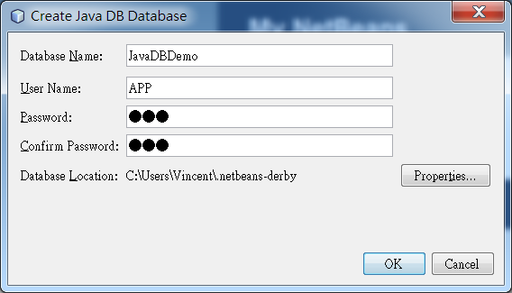
User Name: APP
Password : APP
2. 建立表格
create table SUPPLIERS
(SUP_ID integer NOT NULL,
SUP_NAME varchar(40) NOT NULL,
STREET varchar(40) NOT NULL,
CITY varchar(20) NOT NULL,
STATE char(2) NOT NULL,
ZIP char(5),
PRIMARY KEY (SUP_ID));

create table COFFEES
(COF_NAME varchar(32) NOT NULL,
SUP_ID int NOT NULL,
PRICE numeric(10,2) NOT NULL,
SALES integer NOT NULL,
TOTAL integer NOT NULL,
PRIMARY KEY (COF_NAME),
FOREIGN KEY (SUP_ID) REFERENCES SUPPLIERS (SUP_ID));

create table COFFEE_DESCRIPTIONS
(COF_NAME varchar(32) NOT NULL,
COF_DESC clob NOT NULL,
PRIMARY KEY (COF_NAME),
FOREIGN KEY (COF_NAME) REFERENCES COFFEES (COF_NAME));
create table RSS_FEEDS
(RSS_NAME varchar(32) NOT NULL,
RSS_FEED_XML xml NOT NULL,
PRIMARY KEY (RSS_NAME));
create table COF_INVENTORY
(WAREHOUSE_ID integer NOT NULL,
COF_NAME varchar(32) NOT NULL,
SUP_ID int NOT NULL,
QUAN int NOT NULL,
DATE_VAL timestamp NOT NULL,
FOREIGN KEY (COF_NAME) REFERENCES COFFEES (COF_NAME),
FOREIGN KEY (SUP_ID) REFERENCES SUPPLIERS (SUP_ID));
create table MERCH_INVENTORY
(ITEM_ID integer NOT NULL,
ITEM_NAME varchar(20) NOT NULL,
SUP_ID int NOT NULL,
QUAN int NOT NULL,
DATE_VAL timestamp NOT NULL,
PRIMARY KEY (ITEM_ID),
FOREIGN KEY (SUP_ID) REFERENCES SUPPLIERS (SUP_ID));
create table COFFEE_HOUSES
(STORE_ID integer NOT NULL,
CITY varchar(32),
COFFEE int NOT NULL,
MERCH int NOT NULL,
TOTAL int NOT NULL,
PRIMARY KEY (STORE_ID));
create table DATA_REPOSITORY
(DOCUMENT_NAME varchar(50),
URL varchar(200));
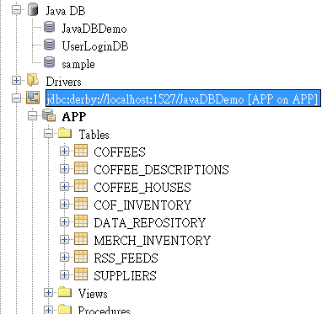
3. 新增資料
insert into SUPPLIERS values(49, 'Superior Coffee', '1 Party Place', 'Mendocino', 'CA', '95460');
insert into SUPPLIERS values(101, 'Acme, Inc.', '99 Market Street', 'Groundsville', 'CA', '95199');
insert into SUPPLIERS values(150, 'The High Ground', '100 Coffee Lane', 'Meadows', 'CA', '93966');
insert into SUPPLIERS values(456, 'Restaurant Supplies, Inc.', '200 Magnolia Street', 'Meadows', 'CA', '93966');
insert into SUPPLIERS values(927, 'Professional Kitchen', '300 Daisy Avenue', 'Groundsville', 'CA', '95199');

insert into COFFEES values('Colombian', 101, 7.99, 0, 0);
insert into COFFEES values('French_Roast', 49, 8.99, 0, 0);
insert into COFFEES values('Espresso', 150, 9.99, 0, 0);
insert into COFFEES values('Colombian_Decaf', 101, 8.99, 0, 0);
insert into COFFEES values('French_Roast_Decaf', 049, 9.99, 0, 0);

insert into COF_INVENTORY values(1234, 'Colombian', 101, 0, '2006-04-01 00:00:00');
insert into COF_INVENTORY values(1234, 'French_Roast', 49, 0, '2006-04-01 00:00:00');
insert into COF_INVENTORY values(1234, 'Espresso', 150, 0, '2006-04-01 00:00:00');
insert into COF_INVENTORY values(1234, 'Colombian_Decaf', 101, 0, '2006-04-01 00:00:00');

insert into MERCH_INVENTORY values(00001234, 'Cup_Large', 456, 28, '2006-04-01 00:00:00');
insert into MERCH_INVENTORY values(00001235, 'Cup_Small', 456, 36, '2006-04-01 00:00:00');
insert into MERCH_INVENTORY values(00001236, 'Saucer', 456, 64, '2006-04-01 00:00:00');
insert into MERCH_INVENTORY values(00001287, 'Carafe', 456, 12, '2006-04-01 00:00:00');
insert into MERCH_INVENTORY values(00006931, 'Carafe', 927, 3, '2006-04-01 00:00:00');
insert into MERCH_INVENTORY values(00006935, 'PotHolder', 927, 88, '2006-04-01 00:00:00');
insert into MERCH_INVENTORY values(00006977, 'Napkin', 927, 108, '2006-04-01 00:00:00');
insert into MERCH_INVENTORY values(00006979, 'Towel', 927, 24, '2006-04-01 00:00:00');
insert into MERCH_INVENTORY values(00004488, 'CofMaker', 456, 5, '2006-04-01 00:00:00');
insert into MERCH_INVENTORY values(00004490, 'CofGrinder', 456, 9, '2006-04-01 00:00:00');
insert into MERCH_INVENTORY values(00004495, 'EspMaker', 456, 4, '2006-04-01 00:00:00');
insert into MERCH_INVENTORY values(00006914, 'Cookbook', 927, 12, '2006-04-01 00:00:00');

insert into COFFEE_HOUSES values(10023, 'Mendocino', 3450, 2005, 5455);
insert into COFFEE_HOUSES values(33002, 'Seattle', 4699, 3109, 7808);
insert into COFFEE_HOUSES values(10040, 'SF', 5386, 2841, 8227);
insert into COFFEE_HOUSES values(32001, 'Portland', 3147, 3579, 6726);
insert into COFFEE_HOUSES values(10042, 'SF', 2863, 1874, 4710);
insert into COFFEE_HOUSES values(10024, 'Sacramento', 1987, 2341, 4328);
insert into COFFEE_HOUSES values(10039, 'Carmel', 2691, 1121, 3812);
insert into COFFEE_HOUSES values(10041, 'LA', 1533, 1007, 2540);
insert into COFFEE_HOUSES values(33005, 'Olympia', 2733, 1550, 4283);
insert into COFFEE_HOUSES values(33010, 'Seattle', 3210, 2177, 5387);
insert into COFFEE_HOUSES values(10035, 'SF', 1922, 1056, 2978);
insert into COFFEE_HOUSES values(10037, 'LA', 2143, 1876, 4019);
insert into COFFEE_HOUSES values(10034, 'San_Jose', 1234, 1032, 2266);
insert into COFFEE_HOUSES values(32004, 'Eugene', 1356, 1112, 2468);
4. 讀取資料
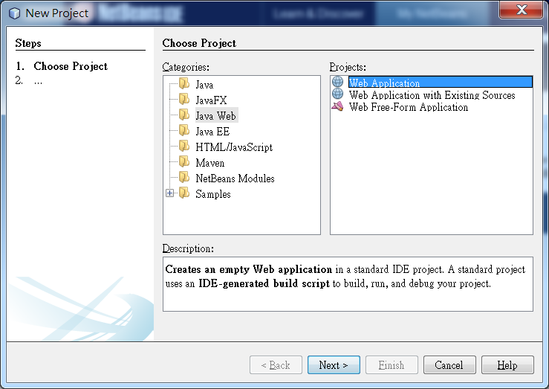
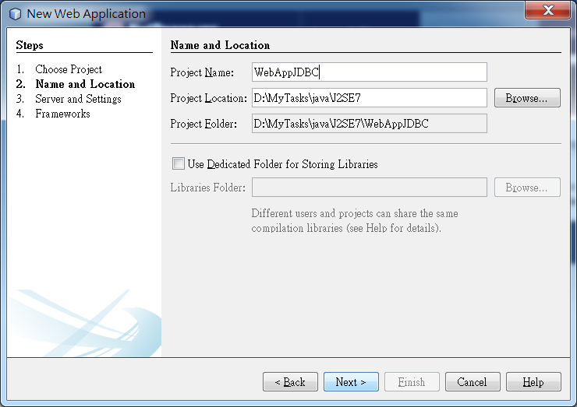
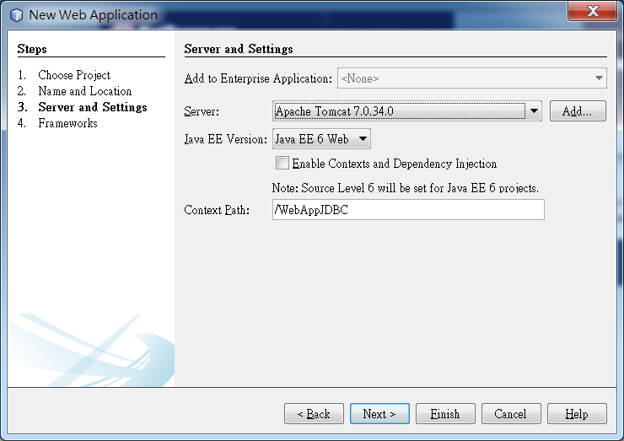
記住:必須加入JavaDB函式庫
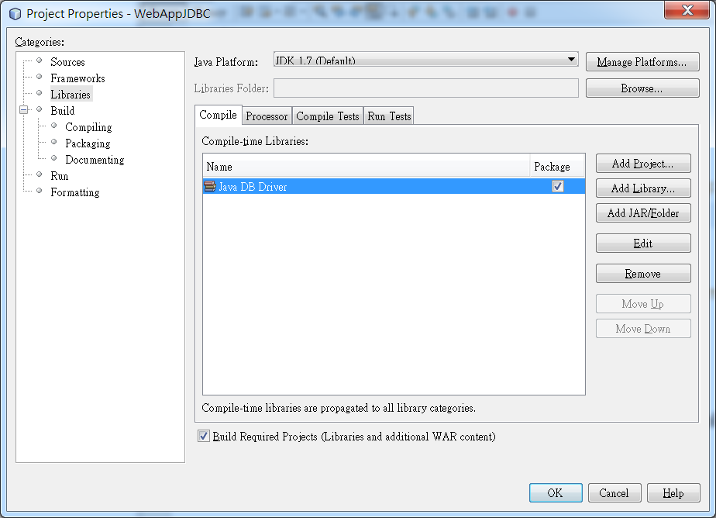
5.編輯index.jsp
<%@page contentType="text/html" pageEncoding="UTF-8"%>
<!DOCTYPE html>
<html>
<head>
<meta http-equiv="Content-Type" content="text/html; charset=UTF-8">
<title>JSP Page</title>
</head>
<body>
<h1>JDBC</h1>
<a href="/WebAppJDBC/SelectSupplier">讀取 Supplier 資料</a>
</body>
</html>
6. 在source package建立Servlet名稱 SelectSupplier

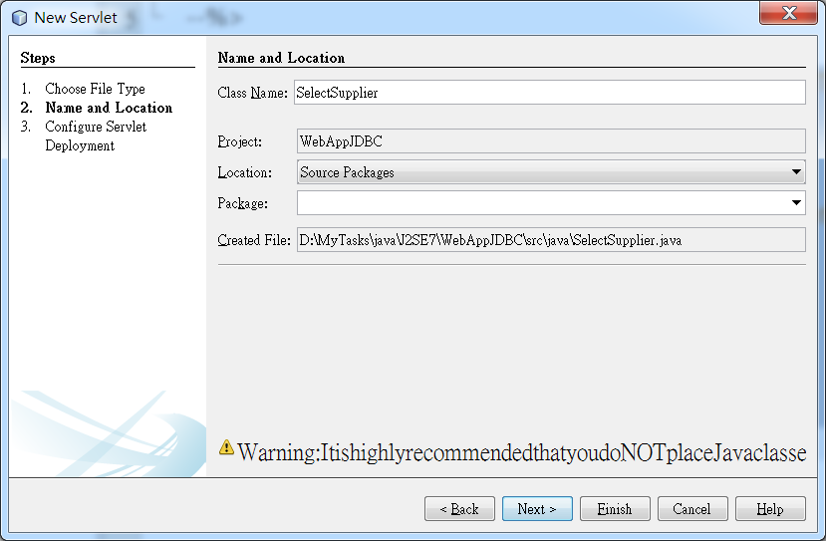

import java.io.IOException;
import java.io.PrintWriter;
import java.sql.*;
import javax.servlet.ServletException;
import javax.servlet.annotation.WebServlet;
import javax.servlet.http.HttpServlet;
import javax.servlet.http.HttpServletRequest;
import javax.servlet.http.HttpServletResponse;

@WebServlet(urlPatterns = {"/SelectSupplier"})
public class SelectSupplier extends HttpServlet {

protected void processRequest(HttpServletRequest request, HttpServletResponse response)
throws ServletException, IOException {
Connection conn=null;
response.setContentType("text/html;charset=UTF-8");
PrintWriter out = response.getWriter();
try {
Class.forName("org.apache.derby.jdbc.ClientDriver");
conn = DriverManager.getConnection("jdbc:derby://localhost:1527/JavaDBDemo","APP","APP");
out.println("<!DOCTYPE html>");
out.println("<html>");
out.println("<head>");
out.println("<title>Servlet SelectSupplier</title>");
out.println("</head>");
out.println("<body>");
viewTable(conn,out);
out.println("</body>");
out.println("</html>");
}
catch(Exception ex)
{
System.out.println(ex.getMessage());
}
finally {
out.close();
}
}

public void viewTable(Connection con,PrintWriter out) throws SQLException {
Statement stmt = null;
String query =
"select SUP_ID, SUP_NAME, STREET, CITY, STATE, ZIP from SUPPLIERS";
try {
stmt = con.createStatement();
ResultSet rs = stmt.executeQuery(query);
out.println("<table border='1'>");
while (rs.next()) {
out.println("<tr><td>");
int supplierID = rs.getInt("SUP_ID");
out.println(""+supplierID);
out.println("</td><td>");
String supplierName = rs.getString("SUP_NAME");
out.println(""+supplierName);
out.println("</td><td>");
String street = rs.getString("STREET");
out.println(""+street);
out.println("</td><td>");
String city = rs.getString("CITY");
out.println(""+city);
out.println("</td><td>");
String state = rs.getString("STATE");
out.println(""+state);
out.println("</td><td>");
String zip = rs.getString("ZIP");
out.println(""+zip);
out.println("</td></tr>");
}
out.println("</table>");
} catch (SQLException e) {
System.out.println(e.getMessage());
} finally {
if (stmt != null) {
stmt.close();
}
}
}

@Override
protected void doGet(HttpServletRequest request, HttpServletResponse response)
throws ServletException, IOException {
processRequest(request, response);
}

@Override
protected void doPost(HttpServletRequest request, HttpServletResponse response)
throws ServletException, IOException {
processRequest(request, response);
}

@Override
public String getServletInfo() {
return "Short description";
}// </editor-fold>
}
